Yohanes Dimas Pratama

A11.2021.13254 - A15.9102

***Exercise of Writing Stories***

Once upon a time, in the not-so-distant past, I embarked on a mesmerizing journey to the enchanting island of Bali. My adventure began when I landed at Ngurah Rai International Airport, where the warm tropical air welcomed me with a gentle embrace. As I stepped off the plane, I knew that this trip would be filled with unforgettable experiences.

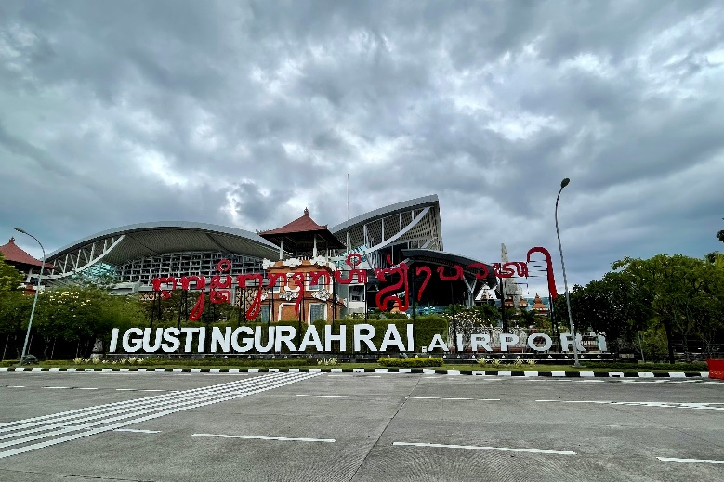

My first destination was the bustling town of Kuta, where I checked into a cozy beachfront hotel. The sound of crashing waves and the view of the sunset from my balcony were nothing short of breathtaking. Over the next few days, I explored the vibrant streets of Kuta, taking in the lively atmosphere, shopping for souvenirs at local markets, and enjoying delicious Balinese cuisine at beachfront restaurants.

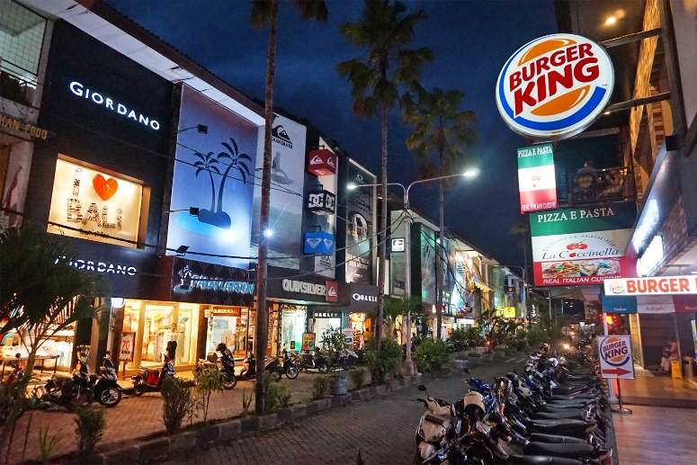

Next, I made my way to Ubud, the cultural heart of Bali. The lush green rice terraces, serene temples, and vibrant art scene captivated my senses. I visited the famous Monkey Forest Sanctuary, where cheeky macaques roamed freely, and explored the Tegallalang Rice Terraces, where farmers worked tirelessly in the fields. Each evening, I attended traditional dance performances that transported me to another world with their intricate costumes and captivating stories.

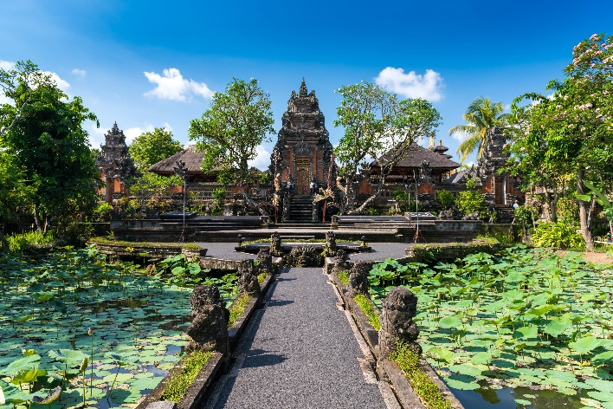

From Ubud, I ventured to the tranquil town of Sidemen, nestled in the heart of Bali's rice paddies and volcanic landscapes. I stayed in a charming homestay overlooking the terraced fields. There, I embarked on picturesque hikes through the countryside, taking in the stunning views of Mount Agung and the surrounding valleys. The simplicity and serenity of Sidemen were a stark contrast to the bustling streets of Kuta and Ubud, and I cherished every moment of tranquility.

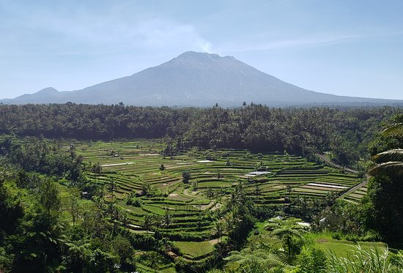

After a few days of relaxation, I headed to the coastal town of Amed. Amed is known for its black sand beaches and incredible snorkeling and diving opportunities. I spent my days exploring the vibrant coral reefs, swimming alongside colorful fish, and even had the chance to spot a few turtles gracefully gliding through the crystal-clear waters. The underwater world of Amed was a mesmerizing experience that left me in awe of Bali's natural beauty.

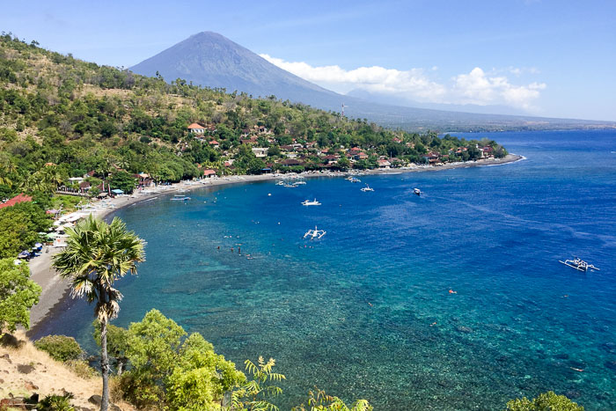

My final destination was Uluwatu, perched on the southern cliffs of Bali. Uluwatu is renowned for its dramatic coastal scenery and the Uluwatu Temple, which sits atop a towering sea cliff. I watched a traditional Kecak dance performance at the temple, where performers chanted and danced to the rhythmic sounds of their voices. The sunset at Uluwatu was a magical spectacle, painting the sky with hues of orange and pink as the waves crashed below.

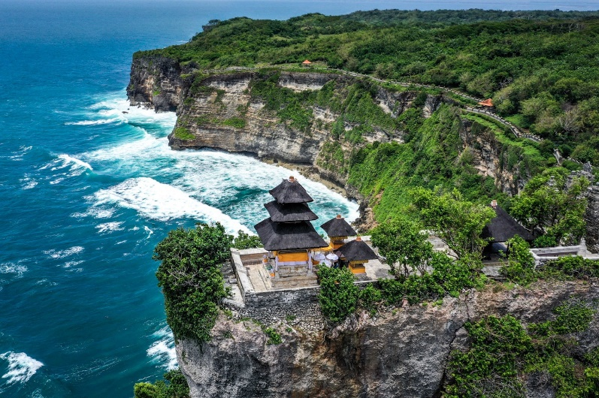

As my journey in Bali came to an end, I reflected on the incredible memories I had created during my travels. From the vibrant culture of Kuta to the serene beauty of Sidemen and the underwater wonders of Amed, Bali had offered me a diverse and unforgettable experience. With a heavy heart, I bid farewell to this enchanting island, knowing that I would carry its beauty and warmth in my heart for years to come.